# Hangman user guide

Welcome to Hangman game. This is a simple console based game.

## How to play?

$ java -classpath hangman.jar org.games.hangman.Hangman

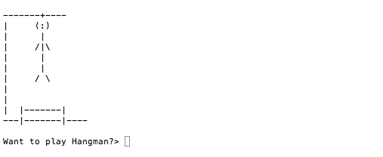

Enter y, yes, yup, yeah, sure, si, or oui to play the game. Otherwise, enter anything else.

Next it will take you to the main menu.

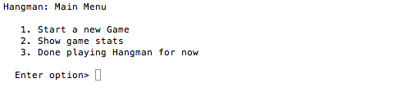

Now, select one of the options. Enter 1 to start a new game.

Next it will present a list of words category.

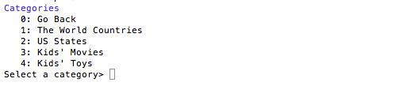

Select a category you want to play.

Want to know a secret? The game by default displays only the above categories. Do you know you can add your own categories, and words for those categories? I will tell you how to do that bit later. By the way, you can do this without changing the code. That’s great, right?

Once you select a category, it will load the words of that category into the game. Now it will pick a random word from this list and you can play Hangman!

Here is your blank game board.

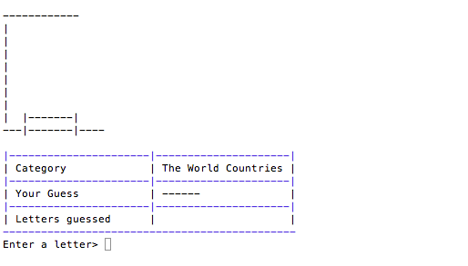

Now enter a letter to guess the word, and have fun!

After you complete each round, it will give you the following game stat.

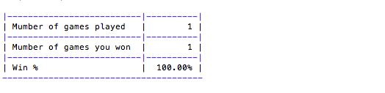

If you could not guess the word in 6 tries, here is how the game board will look like.

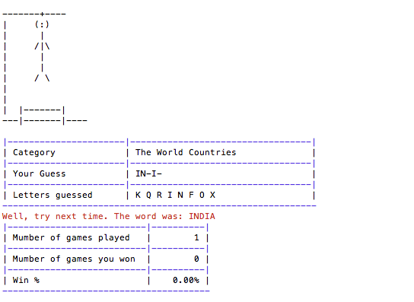

After you complete a game, it will present the following options:

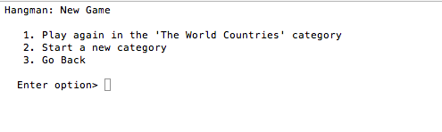

## How to customize the game

The categories are maintained in the categories.txt file in the bin directory. Here is an example:

# Hangman categories

states=US States

toys=Kids' Toys

movies=Kids' Movies

countries=The World Countries

You can change this file to your preference. The first column is the category, and the second column is the display title. The words are saved in the <category>.txt file. Example,

states=US States

The game will display “US States” in the categories list and will load the words from states.txt. So, make sure states.txt exists in the bin directory.

To add a new category say ‘Mathematics’, add the following lines to the categories.txt file.

math=Mathematics

and add the words to ‘math.txt’ file.

When you restart the program, you will see Mathematics in the categories list.

Cool, isn’t it?

JavaScript

How would you teach JavaScript to develop a game

There are several ways

Download games library and use it

Develop simple app using html, css, and JS

Use Canvas

Describe how you would teach javascript to someone who wants to develop a game

Teach JS to develop a game

Take a game

Write down the requirements

Find solutions and functions

Write small modules at a time